PLB/EPIRB/avalanche transceiver registration information

Select device type | PLB / EPIRB / Avalanche
Beacon collection date |  | Beacon return date
Collect/return location
User’s name
Address
Home phone number |  | Mobile number
Passport number |  | Issuer
Drivers licence number |  | Issuer

Trip Itinerary (describe your trip, including group size, dates, start and finish points and significant waypoints):

For EPIRB / PLB: Emergency Contacts
# | Name | Relationship | Home phone | Mobile
1
2

For EPIRB / PLB: Vehicle/Vessel details
Make |  | Model / class
Colour |  | Year
Registration |  | State of registration
Sat. phone number: |  | System

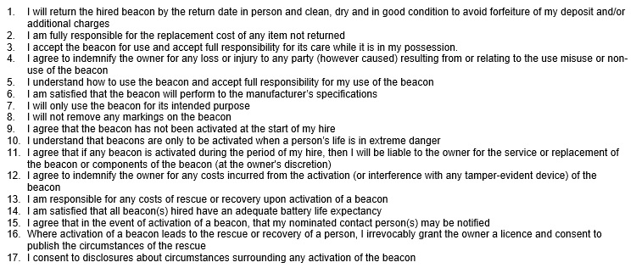

Hirer’s signature

